Drawing a scale for your pipes
Before you make your pipes, you need to make a “scale” for them. Contrary to expectation, scaling pipes equally in all dimensions results in an unpleasant result: the pipes of different pitches will speak with wildly differing volumes and timbres. Because of this, organ designers have come up with clever “scales” that, when utilized, result in pipes that sound consistent across the full range of human hearing.
In his original book, Wicks provided detailed instructions for drawing your own scale. I have reproduced the resulting scale in Figure 1. If that figure doesn’t make much sense to you, spend some time looking at Table 1 which contains all the necessary dimensions, no need for a scale.
However, having the scale drawn out full-sized is very handy. If you want to reproduce it, begin by drawing the long, vertical 54” line, then break that line into a 2’ section, followed by 1’, 6”, 3”, 1-1/2”, and 3/4”. After that, draw the 2-5/8” line perpendicular to the long line at the top of the 2’ section. Connect the two perpendicular lines to form a right triangle. Break the 2’ section into chunks of 2”, the 1’ section into chunks of 1”, the 6” into 1/2”, the 3” into 1/4”, the 1-1/2” into 1/8”, and, finally, the 3/4” into 1/16” sections. Draw another horizontal line 6” from the narrow tip of the triangle to mark the position of the mouth for all the pipes.
Each horizontal line represents the top of one pipe. The lowest two octaves of the scale are labeled with their respective pitches. The rest of the octaves only have C labeled, but the pitches go in the same order.

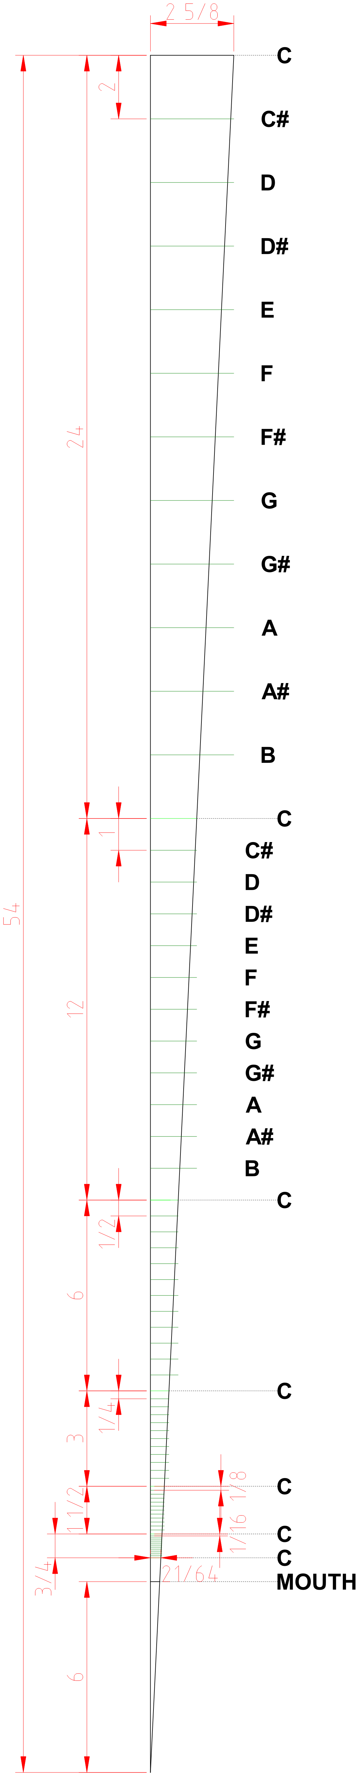Figure 1: Wicks' organ pipe scale. All dimensions in inches.
Table 1: Scale for pipe lengths
Note | Octave | Total length  (inch) | Speaking  length (inch)
C | 2-3 | 54 | 48
C# | 2-3 | 52 | 46
D | 2-3 | 50 | 44
D# | 2-3 | 48 | 42
E | 2-3 | 46 | 40
F | 2-3 | 44 | 38
F# | 2-3 | 42 | 36
G | 2-3 | 40 | 34
G# | 2-3 | 38 | 32
A | 2-3 | 36 | 30
A# | 2-3 | 34 | 28
B | 2-3 | 32 | 26
C | 4 | 30 | 24
C# | 4 | 29 | 23
D | 4 | 28 | 22
D# | 4 | 27 | 21
E | 4 | 26 | 20
F | 4 | 25 | 19
F# | 4 | 24 | 18
G | 4 | 23 | 17
G# | 4 | 22 | 16
A | 4 | 21 | 15
A# | 4 | 20 | 14
B | 4 | 19 | 13
C | 5 | 18 | 12
C# | 5 | 17 1/2 | 11 1/2
D | 5 | 17 | 11
D# | 5 | 16 1/2 | 10 1/2
E | 5 | 16 | 10
F | 5 | 15 1/2 | 9 1/2
F# | 5 | 15 | 9
G | 5 | 14 1/2 | 8 1/2
G# | 5 | 14 | 8
A | 5 | 13 1/2 | 7 1/2
A# | 5 | 13 | 7
B | 5 | 12 1/2 | 6 1/2
C | 6 | 12 | 6
C# | 6 | 11 3/4 | 5 3/4
D | 6 | 11 1/2 | 5 1/2
D# | 6 | 11 1/4 | 5 1/4
E | 6 | 11 | 5
F | 6 | 10 3/4 | 4 3/4
F# | 6 | 10 1/2 | 4 1/2
G | 6 | 10 1/4 | 4 1/4
G# | 6 | 10 | 4
A | 6 | 9 3/4 | 3 3/4
A# | 6 | 9 1/2 | 3 1/2
B | 6 | 9 1/4 | 3 1/4
C | 7 | 9 | 3
C# | 7 | 8 7/8 | 2 7/8
D | 7 | 8 3/4 | 2 3/4
D# | 7 | 8 5/8 | 2 5/8
E | 7 | 8 1/2 | 2 1/2
F | 7 | 8 3/8 | 2 3/8
F# | 7 | 8 1/4 | 2 1/4
G | 7 | 8 1/8 | 2 1/8
G# | 7 | 8 | 2
A | 7 | 7 7/8 | 1 7/8
A# | 7 | 7 3/4 | 1 3/4
B | 7 | 7 5/8 | 1 5/8
C | 8 | 7 1/2 | 1 1/2
C# | 8 | 7 7/16 | 1 7/16
D | 8 | 7 3/8 | 1 3/8
D# | 8 | 7 5/16 | 1 5/16
E | 8 | 7 1/4 | 1 1/4
F | 8 | 7 3/16 | 1 3/16
F# | 8 | 7 1/8 | 1 1/8
G | 8 | 7 1/16 | 1 1/16
G# | 8 | 7 | 1
A | 8 | 6 15/16 | 15/16
A# | 8 | 6 7/8 | 7/8
B | 8 | 6 13/16 | 13/16
C | 9 | 6 3/4 | 3/4

Notes on pipe lengths
In all of Wicks’ rank specifications, he uses a single stopped rank for the lowest octave in the manual range (C2-B2). Recall from earlier that stopped pipes sound an octave lower than their actual measured length. You can also note that each pipe length measured from the mouth of the pipe is, in this scaling, exactly double the length of the pipe of the same pitch an octave higher (e.g., C4 = 24”, C5 = 12”).

